Grade 2
Year 2
Workbook

Index
Week 1-2: Water
Week 3, 4 &5: Our country South Africa
Week 6-7: Communication in our world
Week 8-9: Life at night

Theme: water

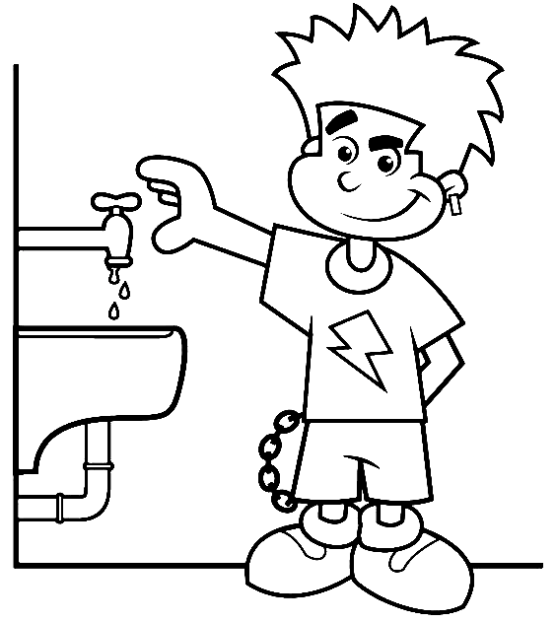
Introduction
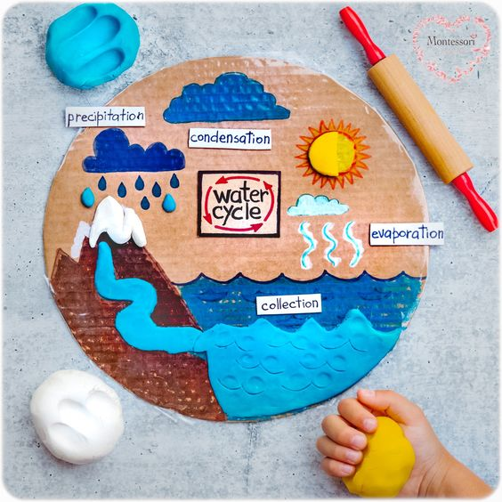

Group 1
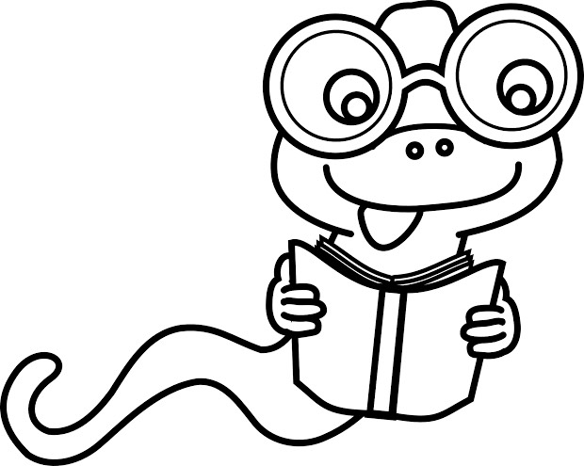

Colour the rain cloud using pencil colours
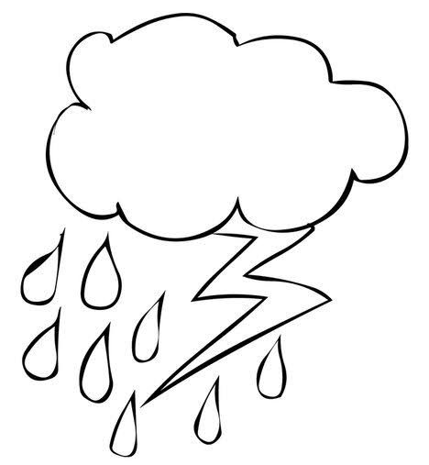

Practical task

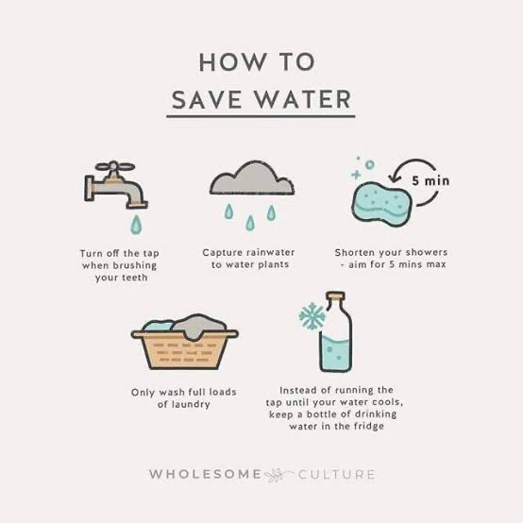

Colour in the water bottle picture below
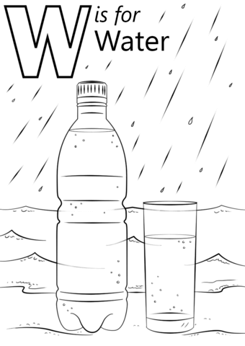

Group 2

Water cycle
Colour in the water cycle
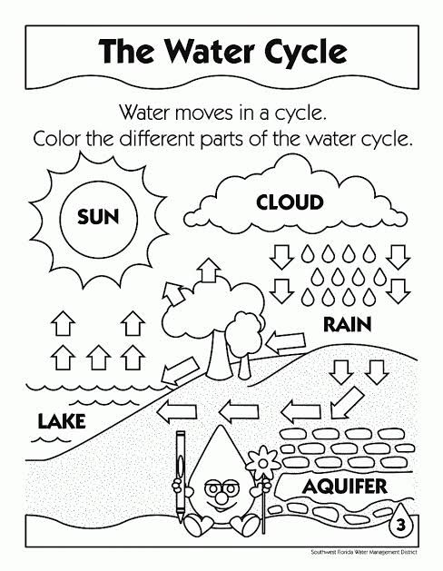

Tick (√) the things you need to use water
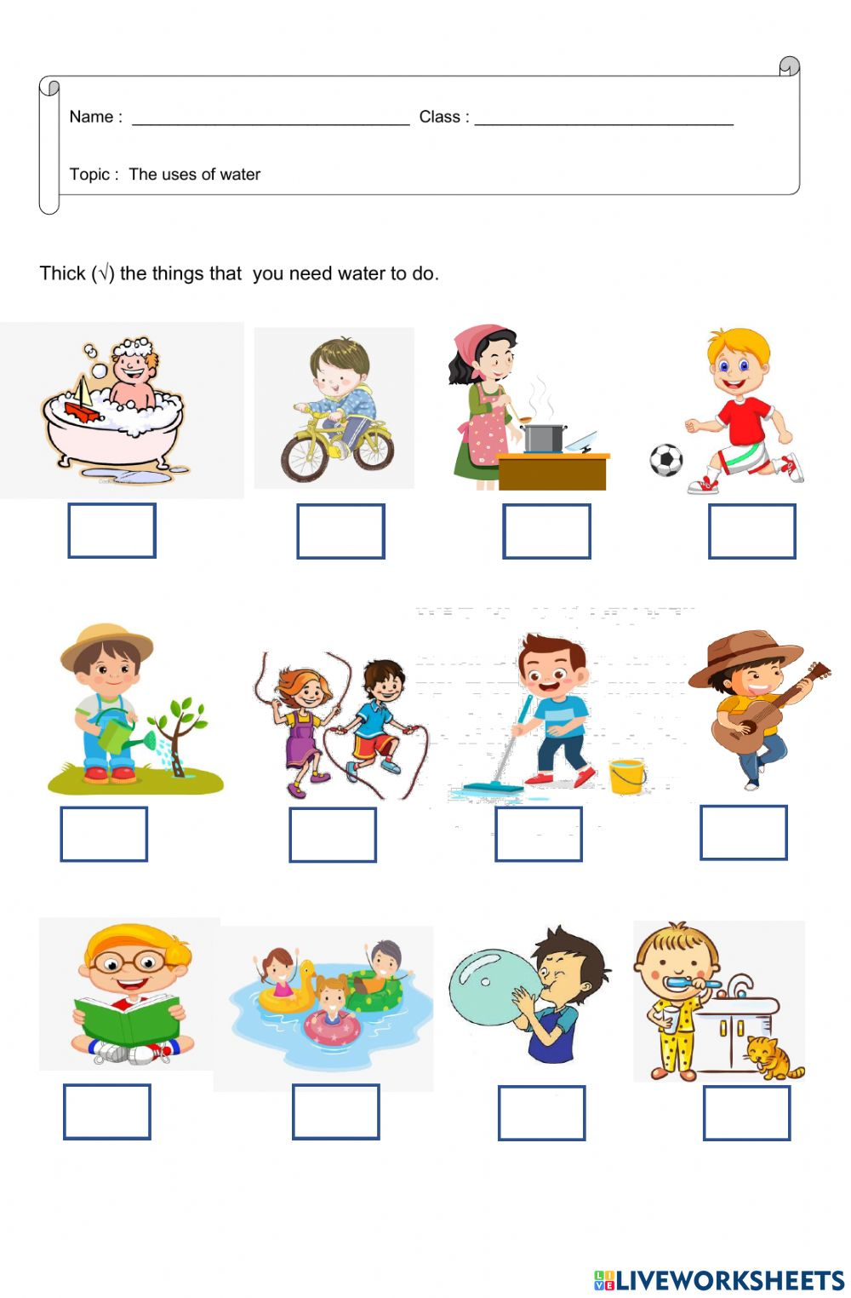

Where do we get water?
Colour the picture below
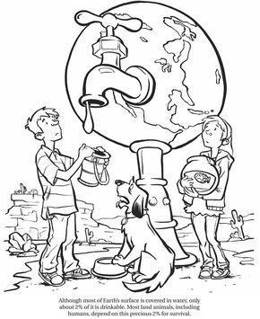

Group 3

The water cycle
Fill in the missing words using the table below
sun | Clouds | land | rain

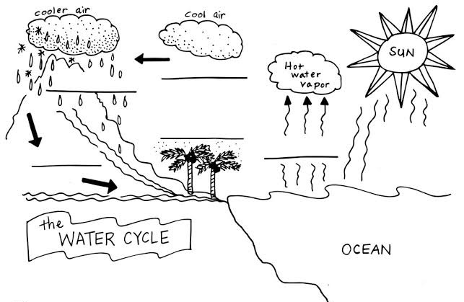

Tick (√) the images that shows the ways we use water.
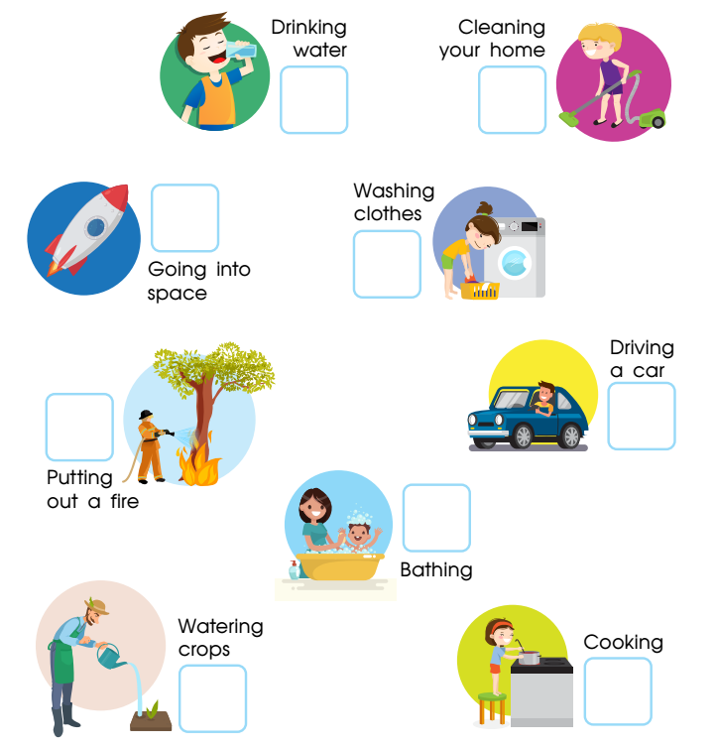

What are the 3 ways you can save water?
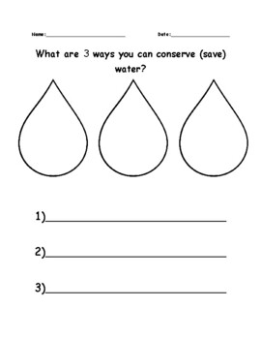

Theme
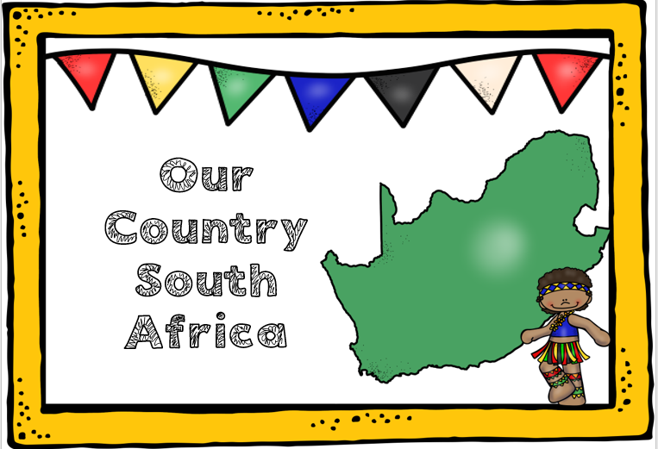

Group 1

Colour the South African flag using; black, red, yellow, green, blue and white
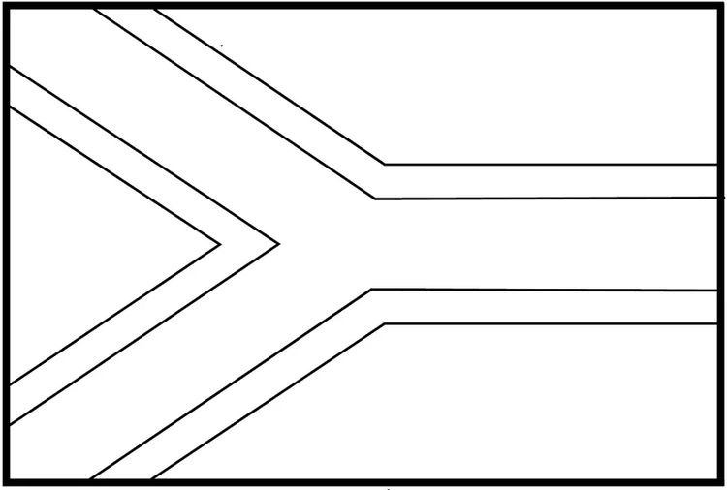

Point out 9 South African provinces
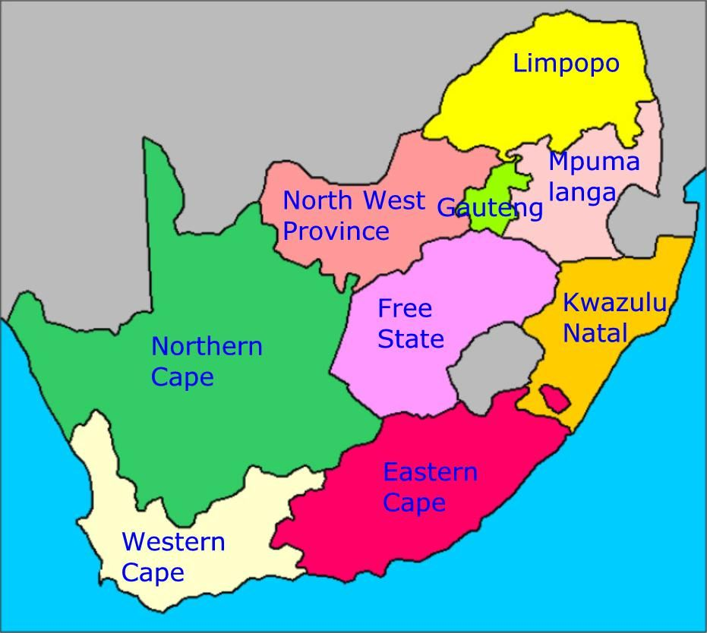

Sing the national anthem
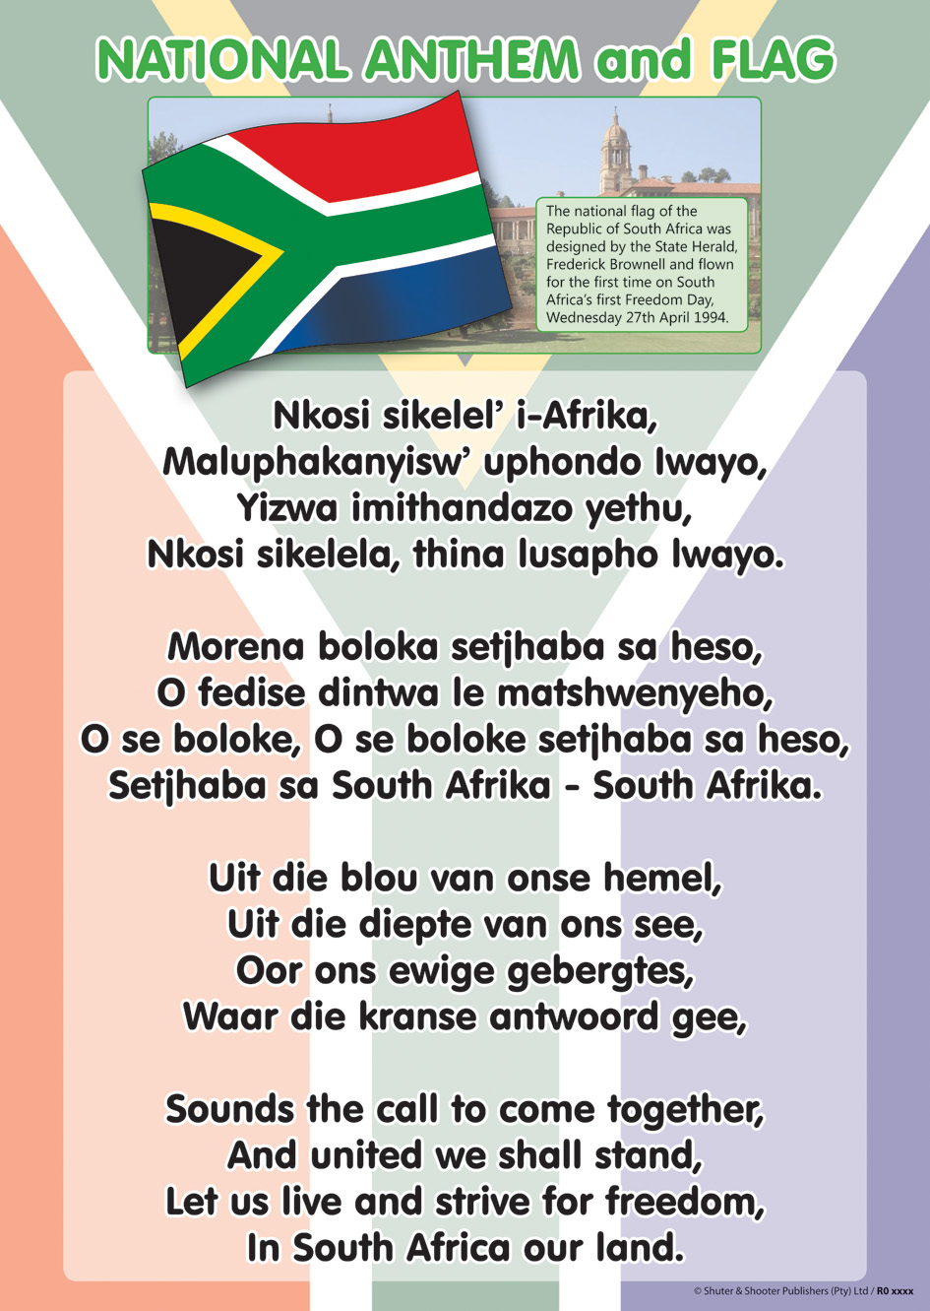
Group 2

Colour the South African flag

Colour 9 South African provinces
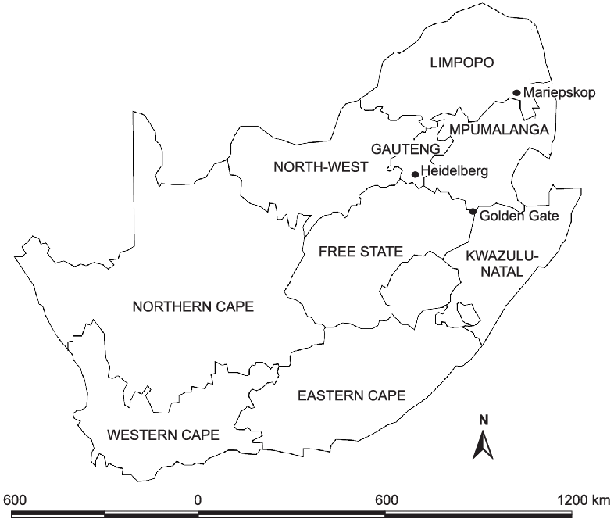

Colour in the national springbok

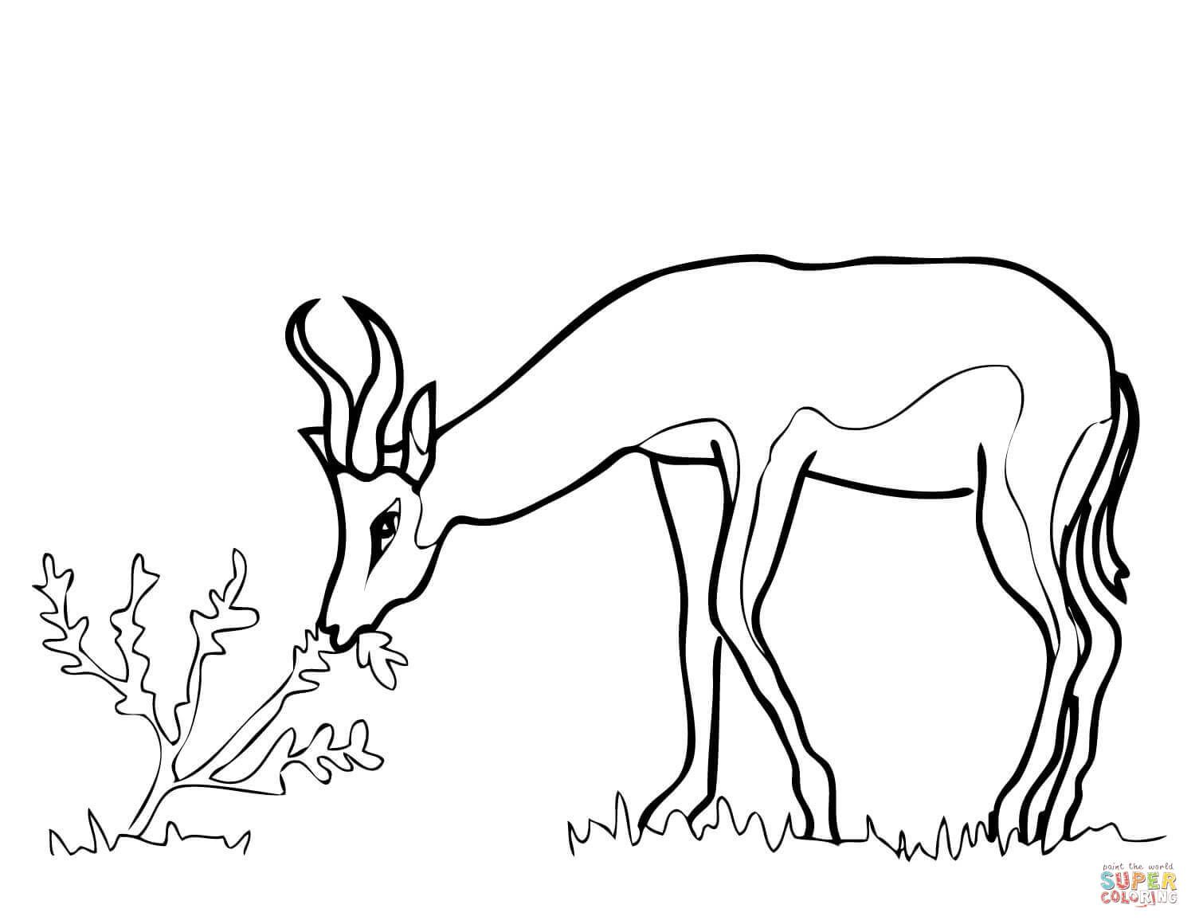

Group 3

Colour the South African flag

Colour in the protea national flower using different colours.
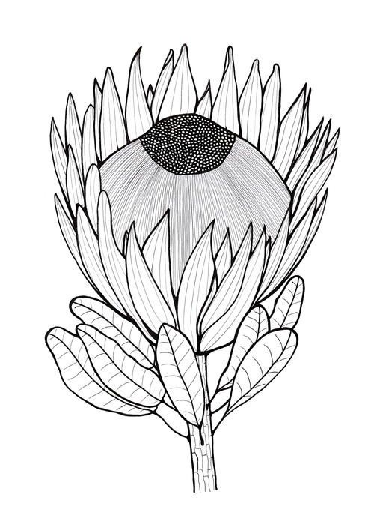
Practical work
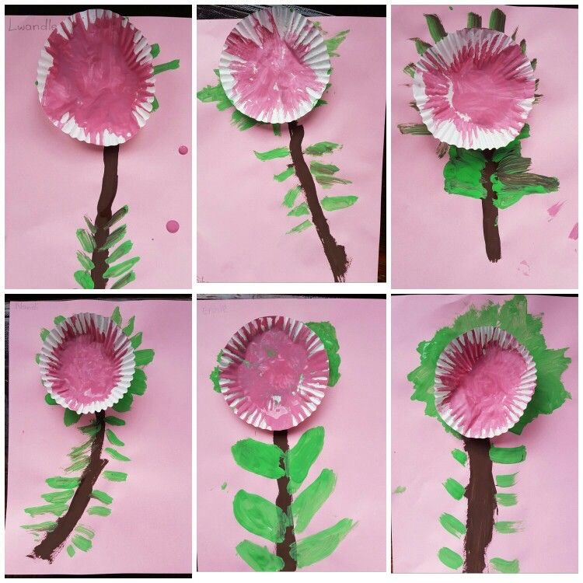

South african Map
Complete and colour the map
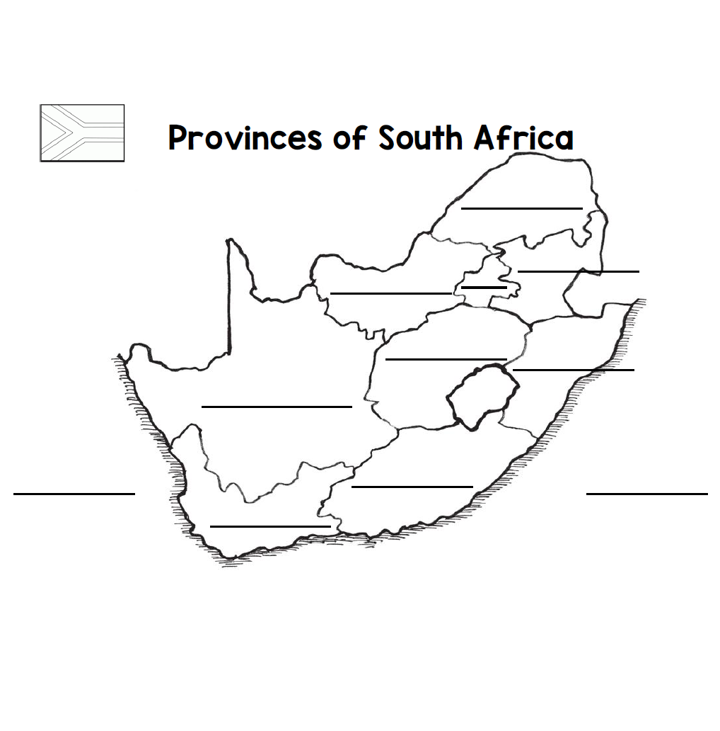

Theme
Communication in our world
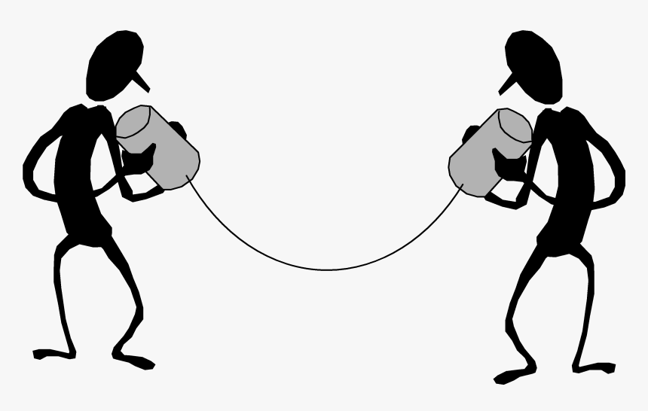
Introduction What is communication?
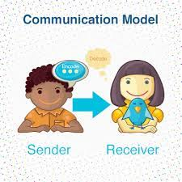
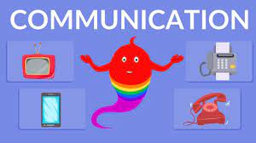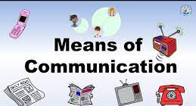
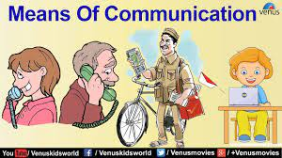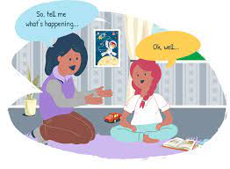
Group 1

Colour in the telephone picture


Colour in the picture below
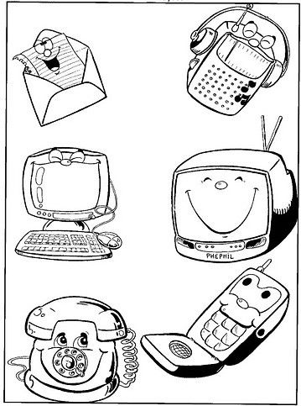
Group 2

Tick the correct form of communication tgat is used now
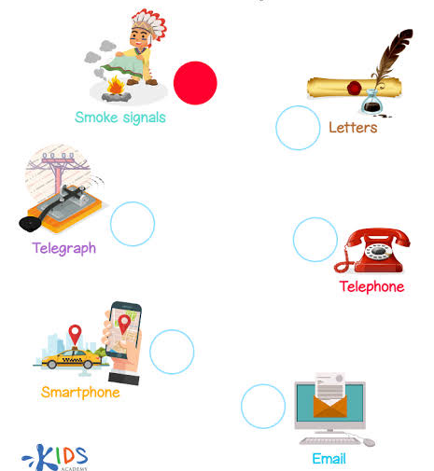

Colour in the correct forms of communication

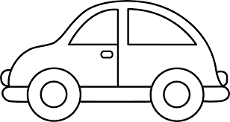
- 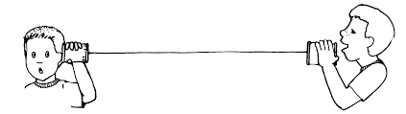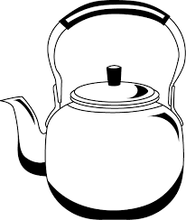

Colour in the mail communication picture below
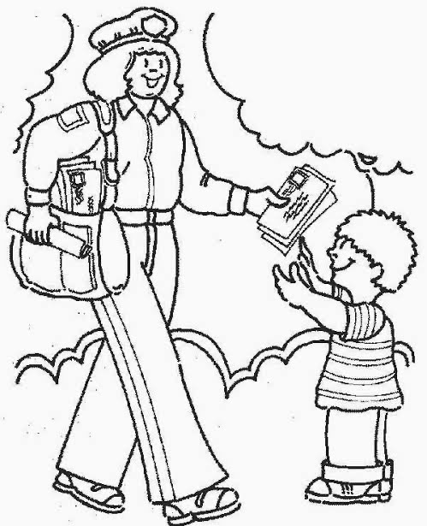
Group 3

Draw any technology gadget that is used for communication

Colour in the picture of verbal communication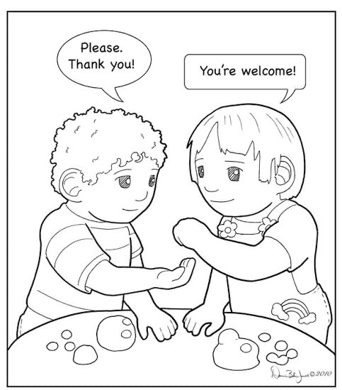

Circle the object that we use to communicate
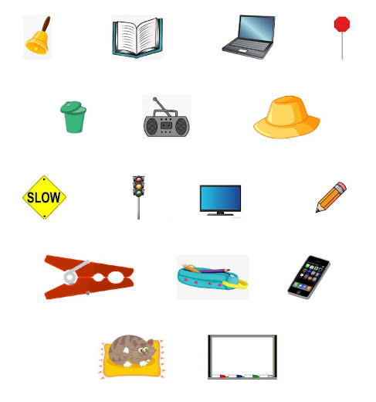

Draw lines to connect the pictures and matching communication tools
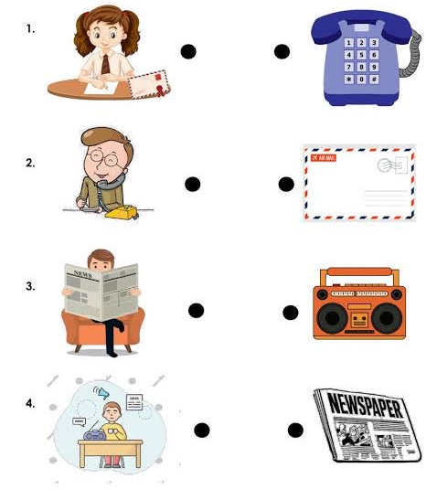
Theme
Life at night
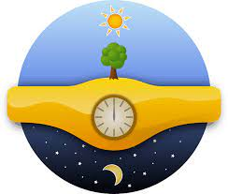
Group 1

Colour in the moon below
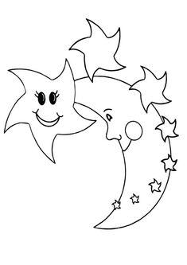

Colour in the star picture below


Group 2

Colour in the moon picture below


Trace and colour in the moon picture below
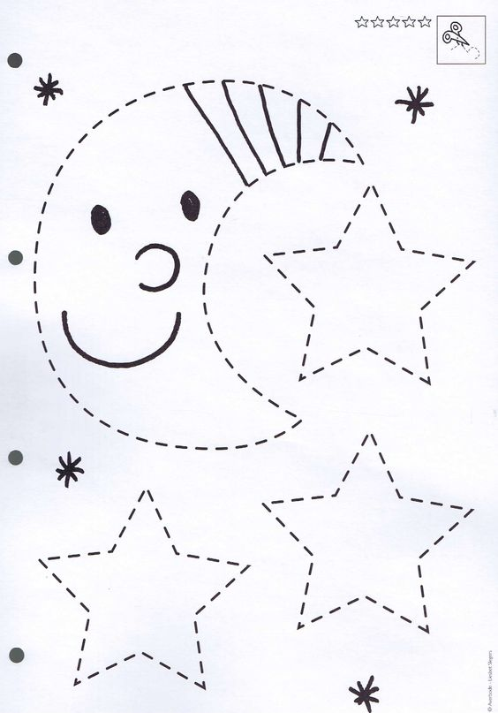

Tick the correct box of what we see at night and during the day
day night
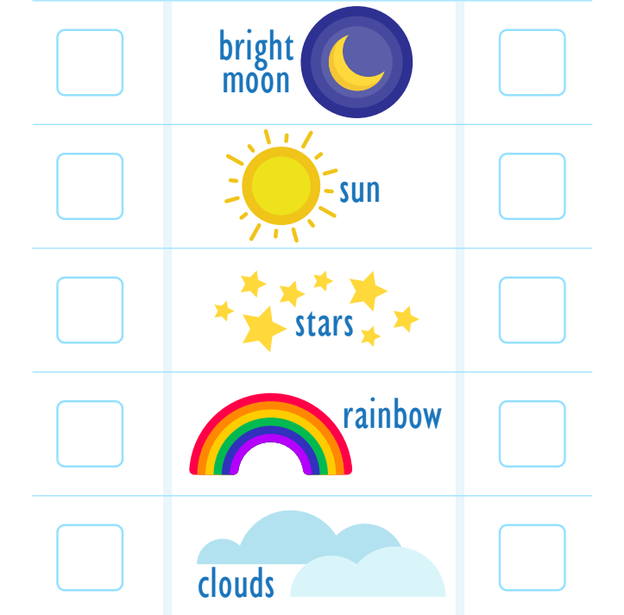
Group 3

Draw and colour in any image that represents night

Colour the images that represent night life
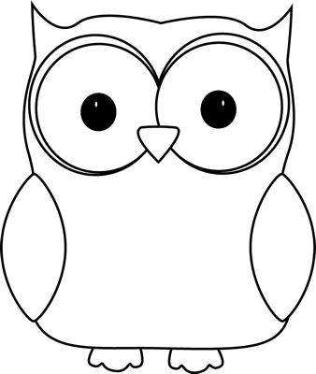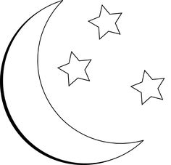
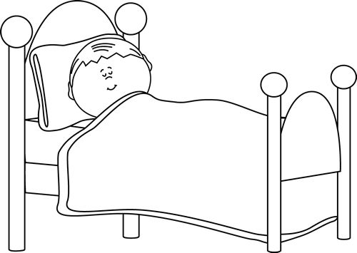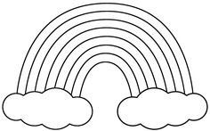
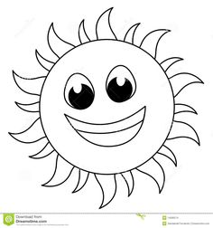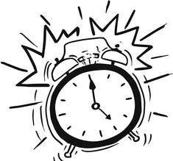
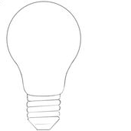

Tick$√$ the correct picture of night time

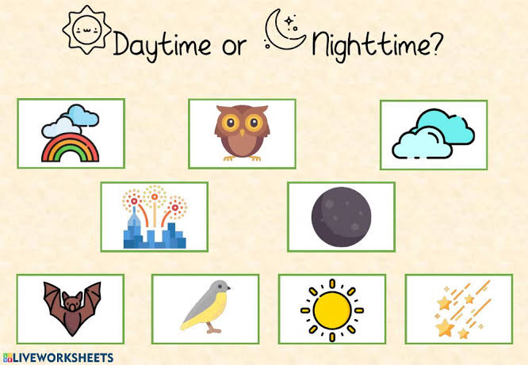

Reference list
Department of Education (DoE), 2002. Revised National Curriculum Statement Grades R-9 (Schools). Life Skills: Life Skills in English-. Pretoria: Department of Education.
Department of Education (DoE), 2003. Revised National Curriculum Statement Grade R-9 (Schools). Teacher’s Guide for the Development of Learning Programmes. Foundation Phase. Pretoria: Department of Education.
Department of Education (DoE), 2008. Foundations for Learning. Government Gazette, Pretoria: Department of Education. Department of Education (DoE), 2008. National Reading Strategy. Pretoria: Department of Education.

